Year 12 MOTION TEST 1 Scotch College
Nov 2009 Time: 50 minutes Total Marks: [50]


- A swimmer in the Rottnest Channel Swim is able to swim at 3.25 km/hr through the water. She encounters a current flowing at 1.50 km/hr from a direction 20° west of south.

- Given that she needs to swim due west to reach Rottnest, in which direction must she swim in order to have a resultant velocity due west? (draw a vector diagram)
[4]

(b) What will be her resultant speed towards Rottnest? [3]

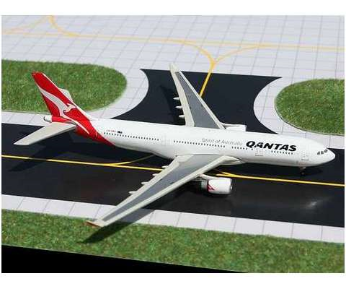
- A Qantas A330 in to land at Perth airport and touches down at 270 km/hr on the 1.5 km long runway.

- Calculate the minimum average deceleration needed by the plane to stop before the end of the runway. [3]
- If the plane actually decelerates at 2.5 m/s² , calculate how long it takes to come to rest after touching down on the runway. [2]

- During the Napoleonic Wars, an artillery commander orders a cannon to fire at the wall of a besieged castle. The cannon shoots its heavy ball from ground level with a muzzle speed of 50 m/s at an angle of 40.0° to the horizontal. The commander estimates the horizontal distance to the wall of the castle to be 200 m and the wall to be 40 m high. Assume that air resistance is negligible.
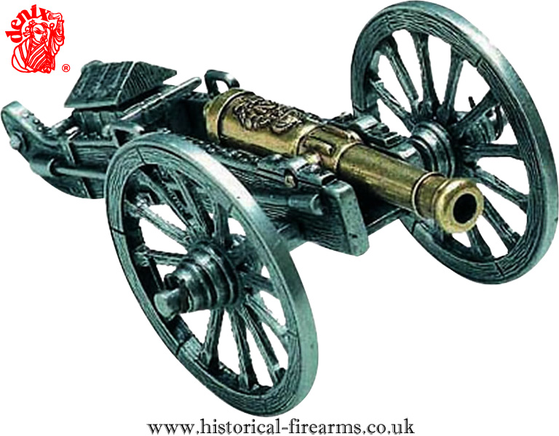
(a) Calculate the components of the initial velocity of the cannonball. [2]

(b) How long does the cannonball take to reach the wall? [2]

(c) At what height does it strike the wall? [3]

(d) What is the maximum height reached by the cannonball during flight? [3]

(e) Calculate the velocity of the cannonball as it hits the wall. [3]

(f) At what angle would the cannon need to be oriented in order to fire the cannonball over the wall? [2]

(g) Draw a sketch highlighting at least three differences between the theoretical path of the cannonball (ignoring air resistance) and the actual path it follows when air resistance is taken into account. [4]
h) Sketch a graph to show for the cannon ball:
i) acceleration verses time ii) vertical displacement verses time [2]

4. A field athlete wants to throw a shotput as far as possible. The throwing action involves projecting the shotput upwards and outwards from the shoulder. Briefly explain why the greatest range for the shotput is achieved using an angle of projection less than 45°. [4]

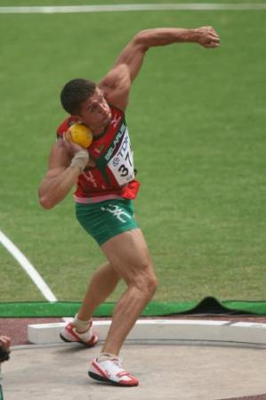

- A car is travelling towards a radar gun at a constant speed. When the driver sees the gun he brakes hard but keeps his deceleration uniform. There are markings on the road every 10 m apart and the police officer records the speed as the car goes past each of these marks. These results are tabulated below.

displacement s (m) | 10 | 20 | 30 | 40 | 50 | 60
velocity v (m/s) | 28 | 25 | 22 | 18 | 11 | 6

The forensic officer knows that the relationship between velocity and displacement is
v² = u² + 2 a s

(a) Modify the data above using the table so that a linear graph can be obtained.
[2]
(b) Draw a linear graph of your modified data.
[4]
(c) From your graph calculate the deceleration of the car and the displacement of the car when it stops. [4]

(d) On inspection of the skid marks the police officer notices that the driver actually applied his brakes 6.0m before the ten metre mark given in the table. Using your graph what was the driver's initial speed before braking? [2]

(e) Which of the speeds recorded seems to be in error? [1]

